**Vector control of Induction Motor via Position of Stator flux and intelligent techniques**

**1Hassan Farhan Rashag, 2Mohammed Hasan Abdulameer, 3Hasan Thabit Rashid Kurmasha**

**1Foundation of Technical Education, Iraq**

**2Department of Computer Science, Faculty of Education forWomen, University of Kufa**

**3Department of Computer Science, Faculty of Education forWomen, University of Kufa**

**ABSTRACT**

The basic idea of direct torque control of induction machines is investigated in order to emphasize the property produced by a given voltage vector on stator flux and torque variations. Direct torque control is an original high performance control strategy in the field of AC drive. The proposed control system is based on space vector modulation (SVM) of electrical machines, neural network, and angle of stator flux. The purpose of this control is to achieve electromagnetic torque and flux without ripple and minimizing distortion of stator current. In this proposed method, PI torque and flux controller are replaced by two neural networks type feed forward neural network to achieve voltages in d-q reference frame that applied to SVM. Stator flux angle is controlled by torque and slip angular frequency. The simulation Results have confirmed exceptional performance in steady and transient states, and show that a reduction of torque and flux ripples is achieved in a complete speed range.

**KEYWORDS**: Direct torque control (DTC), neural network, Stator flux angle, induction motor.

**1. INTRODUCTION:**

Direct torque control (DTC) of induction machines (IM) is a influential control technique for motor drive.It offers high performance in terms of ease in control and fast electromagnetic torque response. Implementation of DTC is based on torque and stator flux hysteresis comparators. It is widely known to produce a quick and fast response in AC drives.

Numerous techniques have been developed to diminish the torque ripple. The pulse duration of output voltage vector is determined by the torque-ripple minimum condition. These improvements can significantly decrease the torque ripple, but they raise the difficulty of DTC algorithm. Much research has been done in DTC and its variants. Some of them used DTC with space vector modulation to produce a performance of the drive in wide speed range and eliminating torque ripple (Xiaoguang Qu., 2010). A different DTC scheme is proposed, with constant switching frequency and fast torque response (Zhifeng Zhang. 2010). DTC improves the dynamic performance of induction motor and reduces the effect of the parameter variation during the operation (Huai Y et al., 2003).

DTC based on space vector modulation (SVM) offers high-quality steady state and active performance by a reduction in phase current distortion with fast response of torque (Domenico et al., 2000). However, this technique has a limitation in computationally intensive. Other researchers have been performed to find different solutions that facilitate the induction motor control to have precise, tough, and speedy torque response (El-Kholy et al., 2005; Khanna et al., 2009). A prognostic controller is used (R. Abdelli et al., 2011) to create the voltage command for inverter control using space vector modulation (SVM). However, the predictive controller uses a feed forward controller and two integrators. Another approach to DTC of IM was obtainable (Nik Ramzi Nik and Abdul Halim Mohamed Yatim, 2001). In this case, the inverter switching for overcoming the disadvantage of the conventional DTC is voltage modulation application replacing look-up table of the voltage vector selection on the basis of 2-level inverter. DTC-SVM control is based on deadbeat for constant control frequency. This needed neither a raise of the sampling frequency, nor a high frequency dither. By best selection of the space voltage vectors in each sampling period, DTC records successful control of the stator flux and torque (Yen Shin Lai and Jian Ho Chen, 2002). Many domestic and foreign scholars have put forward a lot of solutions. Torque and flux are controlled with no deadbeat strategy (Habetler et al., 1992). The technique is composite and with the difficulty of a lot of quantity of computation and precise motor parameters. Discrete space voltage vector method is used (Casadei and Serra, 2000). The complete system is multifaceted and requirements different voltage vectors in different speed. A unified flux and torque control method for DTC-based induction motor drives, and the outcome obtained showed that the planned algorithm reduces the flux and torque ripples (Ryu et al., 2006). In this case, the look-up table in the DTC is replaced by a minimum-distance vector selection scheme to decrease the flux and torque ripples over a fixed sampling period. Different solutions proposed contain DTC with SVM (Ningzhou et al., 2010; Zhifeng et al., 2010) for finest stator flux estimator and high speed operation. Direct torque control based on fuzzy logic and neural network for decoupled stator flux and torque control also this method give good performance and minimize torque ripple (Hongkui Li and Qinlin Wang, 2010; S. Gdaim te al., 2010).

This paper proposes a high transient performance, toughness, and minimizes steady state -torque ripple for direct torque control based on space vector modulation, stator flux angle, and neural network. Simulation results demonstrate the feasibility and validity of the proposed SVM-DTC system by successfully accelerating system response, reducing torque, flux ripple, achieving fixed switch frequency, and improving system performance.

**4. PROPOSED METHOD.**

The proposed method of direct torque control (DTC) using space vector modulation (SVM) is shown in (Figure 3).As it can be noted that there is an evident disparity between the simulation model in this new control system technique for induction motor and classical SVM-DTC. In this proposed method, PI torque and flux controller are replaced by two neural networks type feed forward neural network (FFNN). This proposed method based on space vector modulation, stator flux angle, and neural network to generate voltage in d-q reference frame. The voltages (Vd,Vq) and stator angle will be used as a reference signals in the space vector modulation. Amplitude voltage is based on output voltages from two neural networks. The procedures to execute the model proposed in this paper can be explained as follow:

**4.1. Creation of Network Based Direct Torque Controller.**

The neural network based direct torque controller is designed based on the optimized data set. The neural network is an artificial intelligence technique, which is used for determining the appropriate output via training and testing the data. Here, two input and single output neural network is used for developing the direct torque controller. The input of the network is reference torque and change of torque, the output of the network is control torque. The feed forward type neural network is used for making the optimal direct torque controller. It consist of three layers namely, input layer, hidden layer and output layer. The network structure is shown in Figure4.

In the diagram, the input layer, hidden layer and output layer of the network are denoted as $H_{11}, H_{12}, H_{21}, ….H_{2n} and H_{23}$ respectively. The weights are used to achieve the target control torque value. The weight of the input layer to hidden layer is denoted as ${ w}_{11}, w_{12}, w_{1n}, w_{21}, w_{22} and w_{2n}$. The weight of the hidden layer to output layer is denoted as $w_{211}, w_{221}……..w_{2n1}$. The weight of the network is varied at different instant. The Back Propagation (BP) training algorithm is used for training the network. The training steps involved in the neural network are explained below,

Step 1: Initialize the input, output and weight for each neuron. Here, $T_{e}^{*}$ and ${∆T}_{e}^{*}$ are the inputs of the network and the control torque $\left(T_{e}\right)$ is the output of the network.

Step 2: The inputs of training dataset $T_{e}^{*}$ and ${∆T}_{e}^{*}$ are given to the categorizer and determine the BP error as follows,

$Back propagation error \left({BP}_{error}\right)={\left(T_{e}\right)}_{target}-{\left(T_{e}\right)}_{out}$ (7)

Where, ${\left(T_{e}\right)}_{target}$ is the target output,

${\left(T_{e}\right)}_{out}$ is the network output.

Step 3: Then, the expression of network output is given as following them,

${\left(T_{e}\right)}_{out}=β+\sum_{n=1}^{N}{w_{2n1}T_{e\left(out\right)}(n)}$ (8)

$T_{e\left(out\right)}\left(n\right)=\frac{1}{1-exp\left(w_{1n}T_{e}^{*}+w_{2n}{∆T}_{e}^{*}\right)}$ (9)

The equation (8) and (9) are represents the activation function of output layer and hidden layer respectively.

Where, $β$ is the bias function.

Step 4: The weights of all neurons are adjusted as $w_{new}=w_{old}+∆w$, where, $∆w$ is the change in weight, which can be determined as

$∆w=γ.T_{e}^{NN}.{BP}_{error}$ (10)

Where, $γ$ is the learning rate, usually ranges from 0.2 to 0.5.

Step 5: Repeat the above process from step 2, until BP error gets minimized to a least value i.e, ${BP}_{error}<0.1$. The network training is stopped till the time of minimum back propagation error. Once the process gets completed, the network is well-trained and it would be suitable for providing the control torque values for any reference and change of torque value.

From equation (8), voltage in quadrature reference frame can be expressed as

$V_{sq}=$ (2/3) * (2/p) *Rs* (Lr/Lm) * (${\left(T_{e}\right)}_{out}$/λsref). (11)

PI flux controller is also replaced by neural network but the inputs are flux (λsref) and change of flux(∆λs) and the output is control flux as.

${\left(λ_{s}\right)}_{out}=β+\sum_{n=1}^{N}{w_{2n1}λ_{s\left(out\right)}(n)}$ (12)

$λ_{s\left(out\right)}\left(n\right)=\frac{1}{1-exp\left(w_{1n} λsref+w_{2n}∆λs\right)}$ (13)

The equation (12) and (13) are represents the activation function of output layer and hidden layer respectively. Where $β$ is the bias function.

**5. RESULTS AND DISCUSSION:**

From (Figure 5) and (Figure 6), It can be noted that the ripple of torque in proposed method at low speed (30 rad/sec) is reduced with fast response.In contrast, the torque ripple can not be neglected in classical SVM- DTC. Stator flux in classical SVM- DTC as shown in(Figure 7) maintain circular orbit but with high ripple while the ripple of flux in proposed SVM-DTC is reduced as shown in (Figure 8). In addition، it can be seen that the rotor speed in classical SVM- DTC reach the steady state value within 400 ms as shown in (Figure 9) but in proposed SVM-DTC, the rotor speed reach steady state within 90 ms as shown in(Figure 10). The stator current of traditional SVM-DTC suffer from high starting current with distortion which cause increasing harmonics and degrade the performance system comparing with proposed SVM-DTC as shown in Figure11 and 12 respectively.

The stator flux angle of proposed method is more fast response and straightforward than classical SVM-DTC as shown in Figure 13. Finally, The output signals of space vector modulation are shown in (Figure 14) and these signals show the effectiveness of the proposed controller, also demonstrate high quality for this algorithm to running the induction motor practically especially under heavy load at low speed.

**6. COCLUSION**:

This proposed method describes the performance of direct torque control (DTC) based on space vector modulation, neural network, and stator flux angle. In this system, voltage feeding SVM is more stability because it relies on output voltages from two neural networks controller with estimation voltages in d-q reference frame. The stator flux angle is controlled by PI torque controller and stator angular frequency and this give a high accuracy for the value of the angle due to presence of PI controller. Depending on the position of the stator flux, it is possible to switch on the suitable voltage vectors to control both flux and torque. Then, the output of the stator flux angle with amplitude voltages are applied to the space vector modulation and that is converted in to pulse. The pulse is applied to gate of the inverter and make the switching capability of the inverter is fully utilized and speed of the motor is controlled. This proposed method shows a reduction ability of flux and torque ripple with constant switching frequency and fast response of speed.This control technique can be done practically by using digital signal processing (DSP) board for control of induction motor.

**REFERENCES**:

1. Xiaoguang Qu, (2010) “DTC with adaptive stator flux observer and stator resistance estimator for induction motors,” Paper presented at the 8th World Congress on Intelligent Control and Automation July 6-9 2010, Jinan, China: 2460 – 3.
2. Zhifeng Zhang. 2010. “Novel direct torque control based on space vector modulation with adaptive stator flux observer for induction motors.” IEEE Transactions on Magnetics, 8,3313 –36.
3. Huai Y., Melnik R. V. N., Thogersen P. B., (2003), “Computational analysis of temperature rise phenomena in electric induction motors”, Applied Thermal Engineering, 23, 779-795.
4. Domenico.C., Giovanni Serra, and Angelo Tani (2000)،‘Implementation of a Direct Torque  Control Algorithm for Induction Motors Based on Discrete Space Vector Modulation’, IEEE Transactions on Power Electronics, 15, 769-777.
5. El-Kholy, E.E., Mahmoud, S., Kennel،R., El-Refaei,A., and Elkad, F. (2005)، ‘Torque Ripple Minimization for Induction Motor Drives with Direct Torque Control’, Electric Power Components and Systems، 33, 845-859.
6. Khanna،R., Singla, M.,and Kau, G. (2009)،‘Fuzzy Logic Based Direct Torque Control of Induction Motor’, IEEE Power and Energy Society General Meeting,1-6.
7. R. Abdelli, D. Rekioua, and T. Rekioua,(2011)، ‘Performances Improvements and Torque Ripple Minimization for VSI Fed Induction Machine with Direct Control Torque’,ISA Transactions،50, 213-219
8. Nik Ramzi Nik, and Abdul Halim Mohamed Yatim,(2001),‘Direct Torque Control of Induction Machines with Constant Switching Frequency and Reduce Torque Ripple’, IEEE Transactions on Industrial Applications،16,220-227.
9. Yen Shin Lai, and Jian Ho Chen (2002), ‘A New Approach to Direct Torque Control of Induction Motor Drives for Constant Inverter Switching Frequency and Torque Ripple Reduction’، IEEE Transactions on energy conversion،16, 220-227.
10. Habetler,T.G., Profumo،F., and Pastorelli،M. (1992)، ‘Direct Torque Control of Induction Machines Using Space Vector Modulation’, IEEE Transactions on Industry Application, 28,1045-1053.
11. Casadei,D., and Serra, G.(2000), ‘ Implementation of a Direct Torque Control Algorithm for Induction Motors Based on Discrete Space Vector Modulation’, IEEE Transactions on Power Electronics, 15,769-777.
12. Ryu, J.H., Lee،K.W.,and Lee, J.S. (2006), ‘A Unified Flux and Torque method for DTC-Based Induction -Motor Drives’, IEEE Transactions on Power Electronics, 21, 234-242.
13. Ningzhou Li, Xiaojuan Wei, and Xiaoyun Feng (2010), ‘ An Improved DTC Algorithm for Reducing Torque Ripples of PMSM Based on Fuzzy Logic and SVM’,This Paper Appears in International Conference on Artificial Intelligence and Education, (ICAIE)،401-405.
14. Zhifeng Zhang, Renyuan Tang, Baodong Bai,and Dexin Xie،(2010), ‘ Novel Direct Torque Control Based on Space Vector Modulation with Adaptive Stator Flux Observer for Induction Motors’,IEEE Transactions on Magnetics, 46،3133 -3139.
15. Hongkui Li, and Qinlin Wang,(2010), ‘ Sliding Mode Controller Based on Fuzzy Neural Network Optimization for Direct Torque Controlled PMSM’,IEEE in Intelligent Control and Automation, 2434-2438.
16. S. Gdaim, Abdellatif. M, and Mohamed,F.(2010)، ‘Direct Iorque Control of Induction Machine Based on Intelligent Techniques’, International Journal of Computer Application, 10,29-35.
17. N. Mahendran, and G. Gurusamy،(2011), ‘ Reduction of Torque and Speed Pulsation in Direct Torque Control of Large Induction Motor Using Fuzzy Logic Controller’,European Journal of Scientific Research,48,559-566.







H2N

w12

w1N

w2N

w22

w21

Input layer

Hidden layer

Output layer

w11

H11

H12

H21

H22

H31

w2N1

w221

w211

Figure 4. Structure of Neural Network for PI torque control

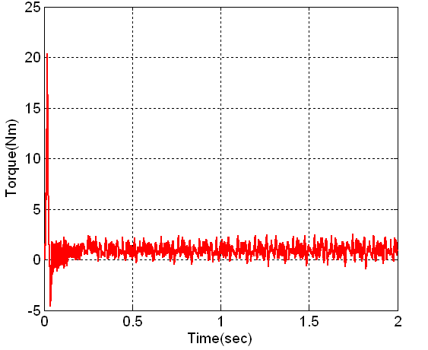 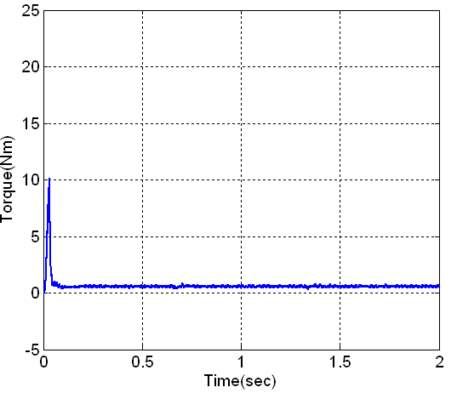

Figure 5. Electromagnetic torque in Figure 6. Electromagnetic torque in

SVM-DTC. proposed SVM-DTC

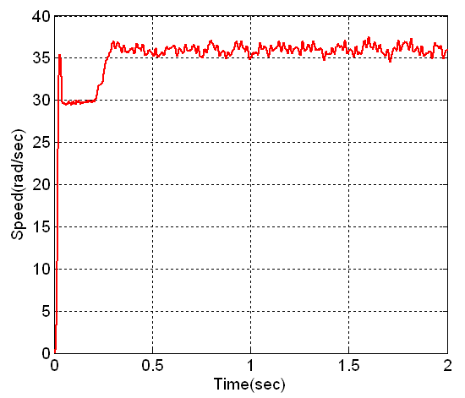 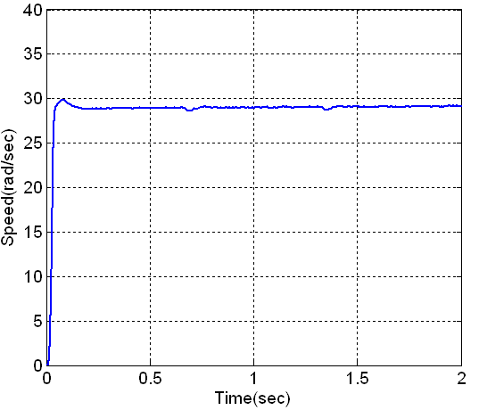

Figure 9. Rotor speed in SVM- DTC Figure 10.Rotor speed in proposed

SVM-DTC

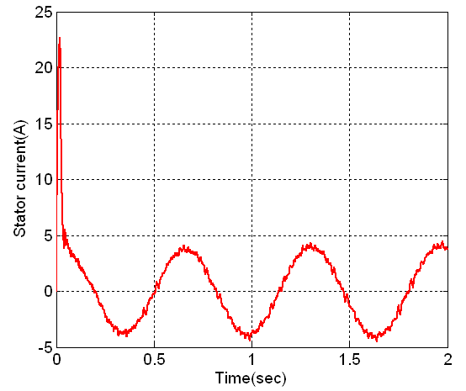 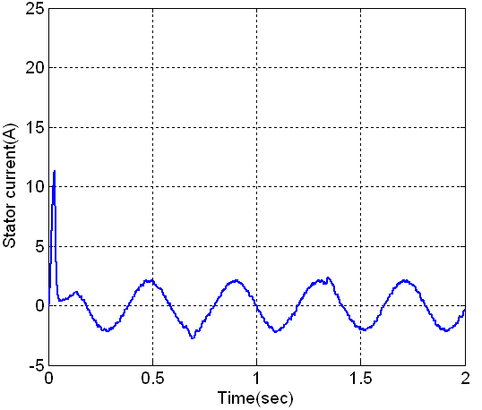

Figure 11.Stator current in SVM- DTC. Figure 12.Stator current in proposed

SVM-DTC

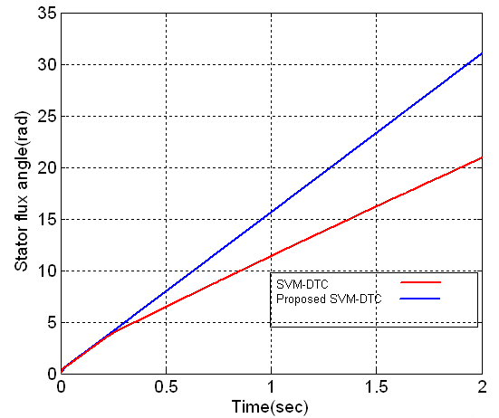

Figure 13. Comparison of stator flux angle

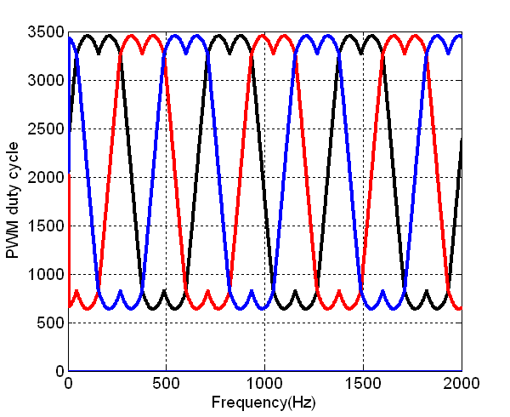

Figure 14.Output signals of SVM